**Walking Pole Instructions**

Thank you for choosing our all-terrain hiking stick. To get the very best performance from this item, please read the following instructions carefully before use.

1. **Your telescopic hiking stick**

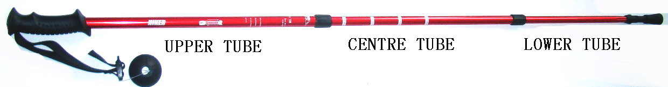

1. **Ergonomic Hand Grip**

The hand grip has been ergonomically shaped for comfort. The slight curve of the grip corrects the position of your wrist, offering improved shock absorption because your hand remains closed at every stage of the walking movement.

1. **Anti-Shock System or Suspension（With ON/OFF function）**

A spring mounted system has been inserted between the upper and central tube to absorb shocks. The suspension will only work properly when both the central and lower tubes are extended in to position. It will not work if you only extend the lower tube.

1. **Stop Marks**

Stop marks are clearly identified on the shaft of the hiking stick of centre and lower tube. Do not extend the tubes of the hiking stick beyond these STOP marks as it may result in damaging the height adjustment mechanism.

d)  **Locking System**

The length of your hiking stick can easily be adjusted to suit you and your terrain. By turning the tubes anti-clockwise the locking system can be opened, allowing you to adjust the length of the centre and lower tubes. Turning the tubes in the other direction will lock them into place. The markings on the hiking indicate the direction in which you should turn the tubes. The height markings on the centre tube are only accurate if the lower tube is set to the stop mark.

**2. Tips and hints**

You may need to re-tighten the locking mechanism from time to time to ensure that it remains firmly locked in place.

NEVER lock the tubes above the “STOP” mark.

**NEVER OVER TIGHTEN.**

We recommend that you adjust your hiking stick according to the terrain as demonstrated in the figures below:



**3. Maintenance**

You all-terrain hiking stick can be easily cleaned with a damp cloth.

From time to time you may need to dismantle the tubes to clean the adjusting screw threads. To dismantle the tubes, unlock them and pull them apart gently. Before you reconnect the tubes, you should ensure that they are fully dried (avoid drying in direct sunlight). Never use lubricants on the screw threads.

**4 Accessories**



**Warning**

The steel tip can be damaged on concrete or hard subsoil. Use the rubber tip to avoid this.

To avoid snapping or damaging the hiking stick, do not bend it more than 15°

This hiking stick is not a toy and is not suitable and intended for use by children.