
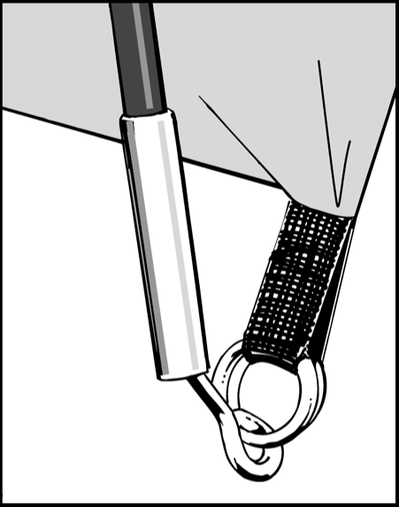
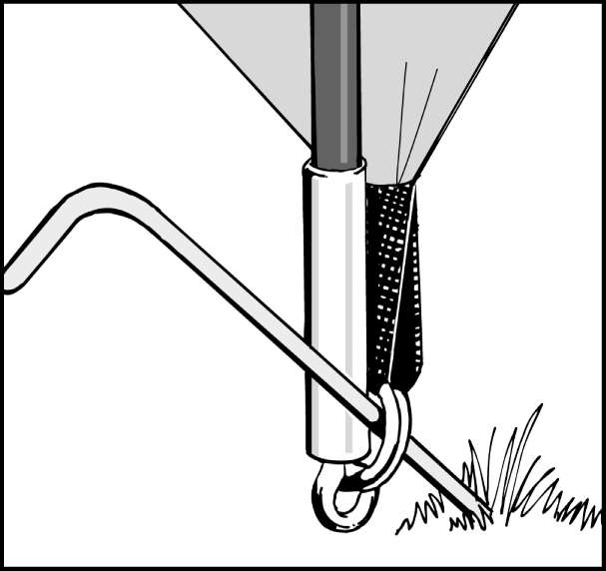
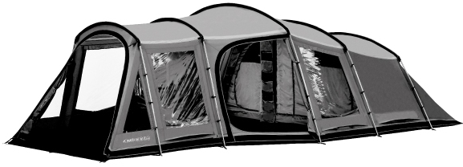
Figure 1
Figure 2

FLYSHEET FIRST PITCHING – Groundsheet is sewn-in

- Assemble poles and lay them parallel on the ground.
- 10 steel upright poles, 5 curved steel roof poles, and 10 angled joining pieces.
- Open out flysheet and position in required direction.
- Ensure the flysheet doors are closed when pitching the tent.
- The poles and joining pieces are colour coded to match the coloured tab on the pole sleeve.
- Locate pole sleeves on roof section of flysheet and insert the curved roof poles.
- Attached the angled joints to the roof poles.
- Insert upright poles into the angled joining pieces.
- On both sides of the tent, loosen the tension straps and locate the ends of each pole into the corresponding ring & pin.
- Attach the clips to the poles and tension the pole end straps.
- Lay pole arches on the ground. The front of the tent should be face down with the back of the tent on top.
- Peg out adjustable anchor straps at both corners of rear end of tent using the V-pegs supplied.
- With one person at each side of the tent gather all the poles together and lift into the upright position
- Pull flysheet forward, away from pegged points, until tent takes shape. Peg the two anchor straps at the front doorway using the V-pegs.
- Ensure the tent is in a straight line. The groundsheet should be flat and wrinkle free.
- Secure the tent using the pin pegs through the ring & pin system – see diagram below.
- Peg out ALL guy lines, ensuring that they are in line with the pole or seam they are attached to.
- Attach the riser porch groundsheet by toggling to the rings on the inside of the flysheet, and clipping to the pole ring and pin system. Peg the groundsheet through the metal eyelet nearest the door to the interior of the tent using the flat top peg.
- The front door has an extra PE flap which should be tucked under the tent groundsheet as an extra seal against rain or wind entry.

INNER ATTACHMENT

- Open out inner tents inside flysheet and position doorway to correspond with the living area.
- Starting from the rear corners of the tent, attach the inner clips to corresponding rings on the tent groundsheet.
- Suspend the inner by attaching toggles of inner tent through rings on inside of flysheet. Do the rear first and work forward.
- Attach the base of the pelmet to the attachment points on the front of the inners.
- Attach wardrobe pole to hanging pole clips in the centre inner tent.

Tent Pitching Instructions – Maritsa 500, 600 & 700
Ring and Pin System
- Locate one end of each pole onto the corresponding metal pin. The metal pin inserts into the hollow metal ferrule on the end of each pole. (See Figure 1). Push the pole into a curve from the opposite side, one at a time, and locate all pole ends onto the metal pins.
- Peg the corners of the tent through the metal rings using pin-pegs. It is important to drive the peg into the ground at a 45 degree angle to obtain the best grip. (See Figure 2).

