
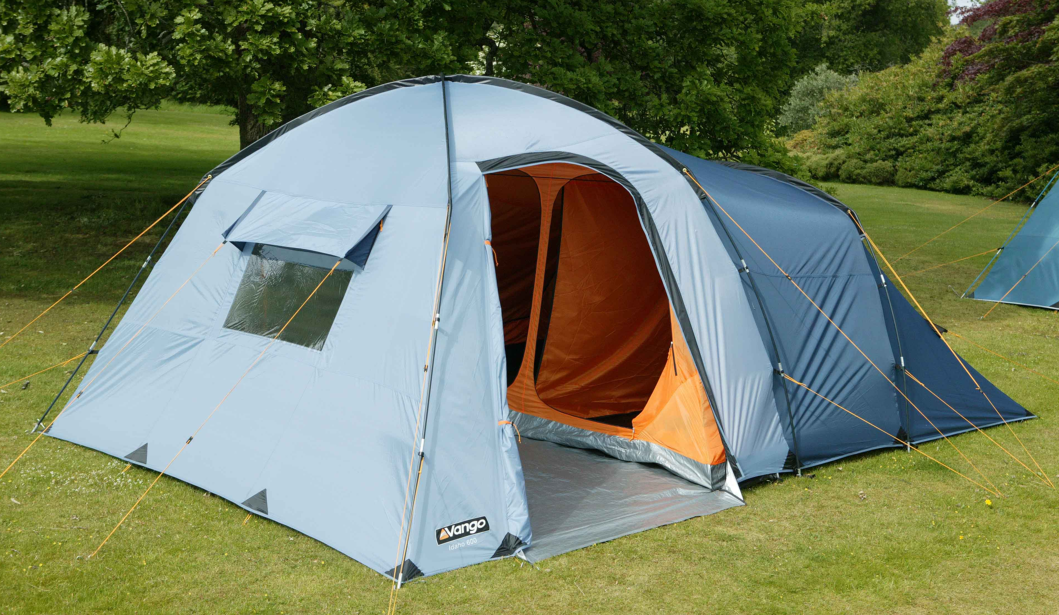

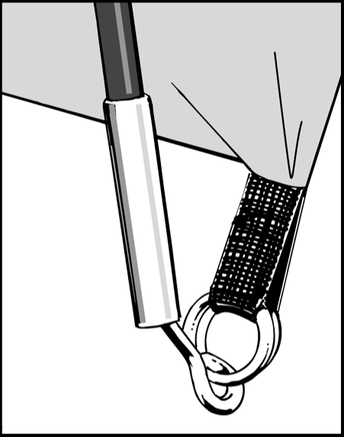
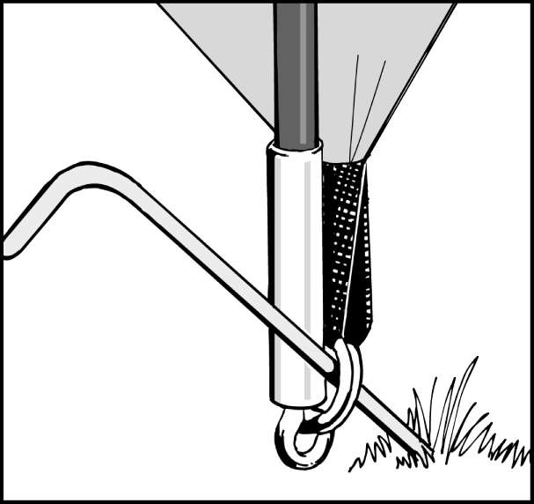
Figure 1.
Figure 2.

FLYSHEET FIRST PITCHING –

The Groundsheet is sewn-in place

- Assemble poles and lay them on the ground parallel:
4 poles: 2 long poles for the main dome
1 medium pole for the bedroom
1 small brow pole.
The poles are colour coded to match corresponding pole sleeve entry points.
- Open out flysheet and position in required direction.
- Insert the poles through the colour coded pole sleeves on the outside of the flysheet.
- Locate one end of each pole on one side of flysheet, into the metal pin system at the end of the pole sleeves. Make sure poles locate into correct pin system (all poles follow corresponding flysheet seams to pin system).
- (To avoid excess strain on poles and tent material, it is advisable to have assistance to hold diagonal poles upright when forming arch).
- Push poles into an arch from opposite ends and locate pole ends into corresponding metal pin.
- Clip all flysheet pole clips to inserted poles
- Start pegging out the tent using the main corners at the rear of the tent using the steel v-channel pegs
- Pull the tent forward until taught and peg out the main corners at the front of the tent, again with the steel v-channel pegs
- The groundsheet should be flat and wrinkle free.
- Secure the tent using the pin pegs through the ring& Pin system – see diagram right.
- Peg out flysheet fillets to tension flysheet.
- Peg out ALL guy lines using pin-pegs ensuring that guy line fabric attachment points are evenly tensioned.
- Inside the tent insert brow pole through white ring in roof above door of inner.
- Locate pole ends in metal rings

- Ring and Pin. Locate one end of each pole onto the corresponding metal pin. The metal pin inserts into the hollow metal ferrule on the end of each pole. (See Figure 1). Push the pole into a curve from the the opposite side, one at a time, and locate all pole ends onto the metal pins.
- Peg the corners of the tent through the metal rings using pin-pegs. It is important to drive the peg into the ground at a 45 degree angle to obtain the best grip. (See Figure 2).

INNER ATTACHMENT

- Open out inner tents inside flysheet and position doorway to correspond with the porch and entrance of the flysheet.
- Starting from the rear corners of the tent, attach the elasticated hooks on the groundsheet to corresponding rings on the flysheet anchor straps.
- Suspend the inner by attaching toggles of inner tent through rings on inside of flysheet. Do the rear first and work forward towards the porch.

Tent Pitching Instructions – Idaho 400, 500 & 600
Figure 2.

